Part I Tuan Nguyen

**Why learn and use C?**

-The C programming language was devised in the early 1970s as a system implementation language for the nascent Unix operating system. Derived from the typeless language BCPL, it evolved a type structure; created on a tiny machine as a tool to improve a meager programming environment, it has become one of the dominant languages of today. It was designed to be compiled using a relatively straightforward compiler, to provide low-level access to memory, to provide language constructs that map efficiently to machine instructions, and to require minimal run-time support. C language was the object-oriented language for a while, is still heavily used, and has inspired other highly popular object-oriented languages such as C# and Java. C++ has dominated the “system programming” market and changed how many of us think about programming from completely procedural to object-oriented thinking. So, the question is “Why do we learn and use C programming language”. Programming in C is fairly easy because it uses basic commands in English. Also, learn C help programmers easier pick up other languages, like Java, C#, C++, and Python.

Part II

**Defining the Problem and your Approach Towards Finding a Solution**

Flow diagram

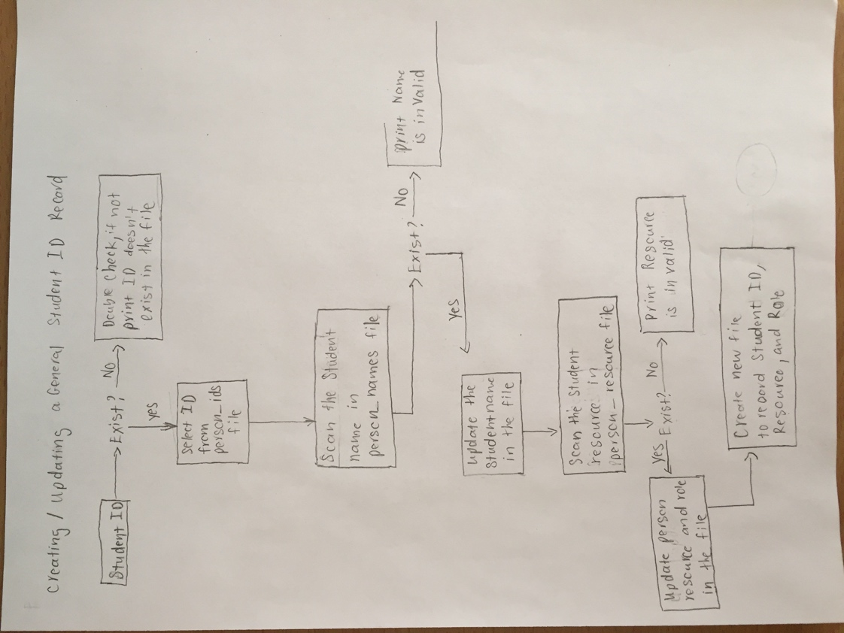

Part III

**Writing Pseudo-code**

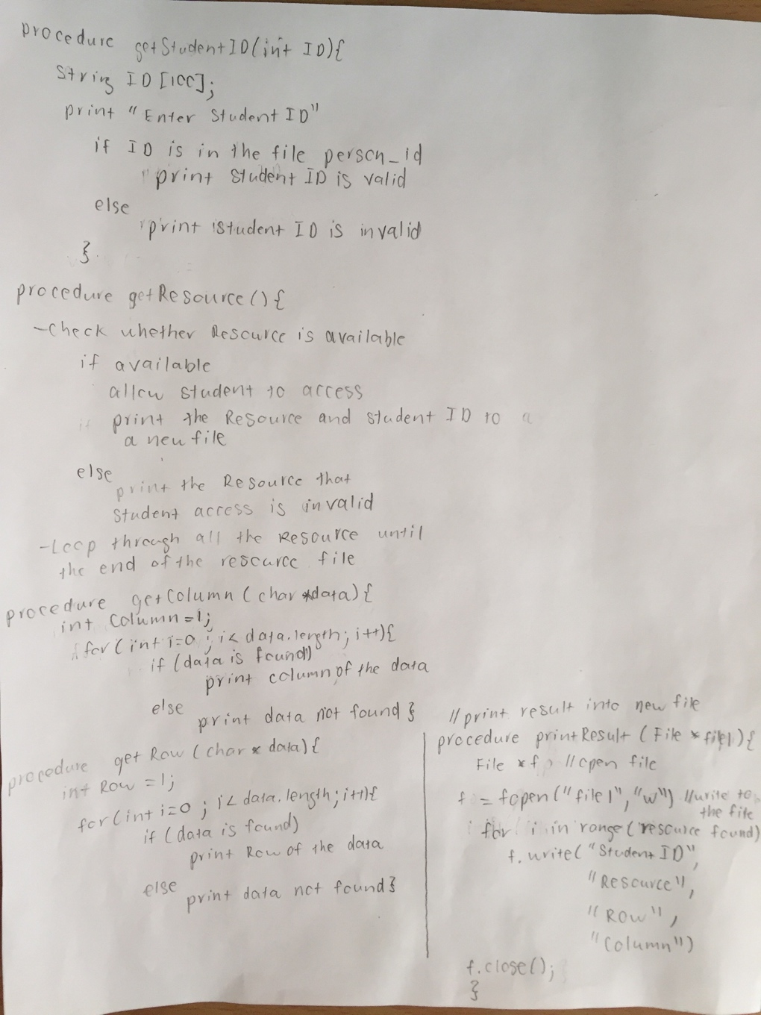Implement 5 functions: getStudentID, getResource, getColumn, getRow, printResult.

Part IV

**Implementing the Solution**

Compiling your project:

cd desktop

cd assign6

ls

gcc -o assign6 db_helper.c assign6.c main.c

./assign6